Olusegun Afolabi
EECE 412
Prof Wenjie
4/1/2025

Lab 9
Part 1
Introduction
The design and implementation of digital systems increasingly rely on abstraction through hardware description languages like VHDL, enabling engineers to focus on high-level functionality rather than gate-level logic. This lab explores one of the foundational components in digital design: the counter. Counters are essential for sequencing operations, timing delays, frequency division, and numerous state-based applications in both control and data-path systems.
In this experiment, we investigate two distinct methods of describing counter behavior in VHDL: using process blocks (sequential logic) and non-process conditional signal assignments (combinational logic). Both implementations are synthesized to the FPGA to observe their behavior and structural differences, thereby enhancing our understanding of VHDL coding styles and their hardware implications.
Concept
At the core of this lab lies the comparison between two VHDL design techniques:
- Counter 1 is described using concurrent conditional signal assignment statements, which represent a purely combinational logic approach for calculating the next state. These statements are interpreted by synthesis tools as logic gates and multiplexers, depending on signal conditions.
- Counter 2 uses a process block to implement the same counter functionality. This sequential style allows conditional operations to occur based on clock edges and reset signals, which is more suited for control-oriented designs and is typically used for state machines or pipelined systems.
Each counter is connected to an LED output that reflects the state of its most significant bit (MSB). The ctrl signal vector provides independent control for counting and output visibility, allowing us to observe differences in behavior during synthesis and hardware execution.
By analyzing the resulting schematic from Vivado, this lab emphasizes the importance of understanding how VHDL coding styles translate into hardware resources such as registers, adders, and multiplexers. It also highlights how design abstraction in VHDL impacts the physical and logical implementation on FPGA devices
Procedures
- A new project was created in Vivado, with the VHDL language selected as the target HDL and the Basys 3 FPGA board chosen from the board selection list.
- The provided VHDL source code implementing two counters (cnter1 and cnter2) using different styles (non-process and process-based) was entered into a new Design Source file and added to the project.
- The Basys 3 master constraint file (.xdc) was added to the project, and edited to match the VHDL port assignments:
- Switches SW0–SW4 were mapped to reset and ctrl(3:0).
- LEDs LD0–LD1 were mapped to leds(0) and leds(1).
- The system clock was enabled using the 100 MHz on-board clock on pin W5 with proper timing constraints.
- After verifying the code syntax with Run Linter, the Open Elaborated Design tool was used to visualize the synthesized schematic.
- Screenshots of the Part 1 VHDL code and the Vivado RTL schematic were captured for documentation.
- The schematic components were compared and matched to the VHDL constructs (e.g., adders, registers, multiplexers) to analyze how cnter1 and cnter2 were implemented structurally.
- The design was synthesized, implemented, and the bitstream file was generated. Then, the project was successfully programmed to the Basys 3 FPGA hardware.
- Switch-based tests were performed on the FPGA:
- Control switches (ctrl(3:0)) were toggled in various configurations.
- Observations of LED[0] and LED[1] were recorded to verify correct behavior of each counter.
- Photos were taken for each input combination to validate LED responses (e.g., ON, OFF, or BLINKING).

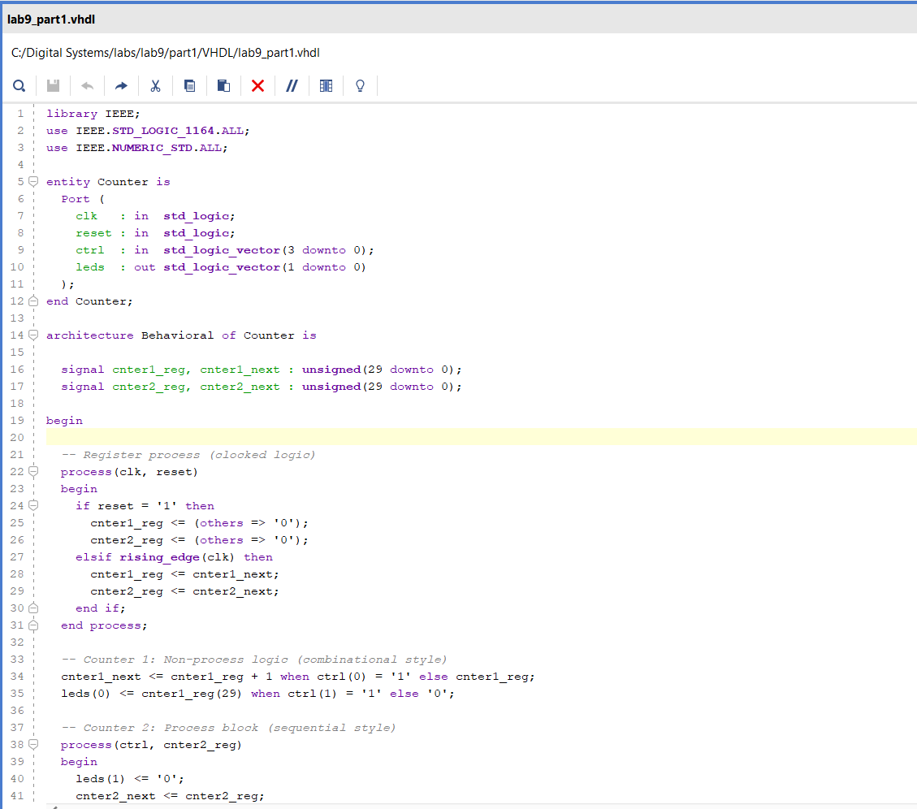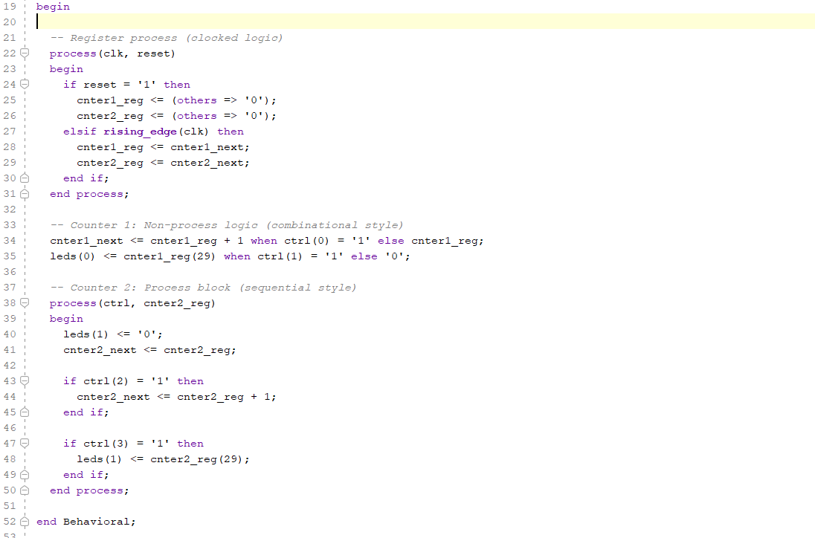
Questions:
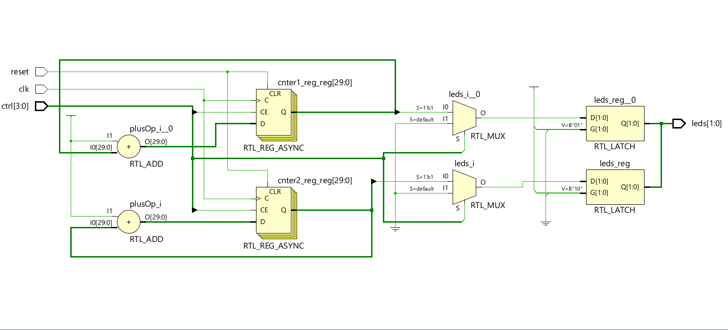
Part 1

(a) Identify the components in the schematic that correspond to your VHDL code which implements the two counters cnter1 and cnter2.

🔍 Counter 1 – cnter1 (Non-process style using conditional assignment)
VHDL Code Snippet | Schematic Component
cnter1_next <= cnter1_reg + 1 when ctrl(0) = '1' else cnter1_reg; | plusOp_i_0 → RTL_ADD
 | leds_i_0 → RTL_MUX
leds(0) <= cnter1_reg(29) when ctrl(1) = '1' else '0'; | MUX controlled by ctrl(1) to drive LED0
Register for cnter1_reg | cnter1_reg_reg[29:0] → RTL_REG_ASYNC
LED output logic | leds_reg_0 → RTL_LATCH

🔍 Counter 2 – cnter2 (Process block style)
VHDL Code Snippet | Schematic Component
Process block with if ctrl(2) = '1' then cnter2_next <= cnter2_reg + 1; | plusOp_i → RTL_ADD
leds(1) <= cnter2_reg(29) when ctrl(3) = '1' | leds_i → RTL_MUX
leds(1) <= cnter2_reg(29) when ctrl(3) = '1' | Controlled by ctrl(3)
Register for cnter2_reg | cnter2_reg_reg[29:0] → RTL_REG_ASYNC
LED output logic | leds_reg → RTL_LATCH

1(b) Compare the schematic of these two counters cnter1 and cnter2:
Aspect | cnter1 (Non-process) | cnter2 (Process-based)
Adder location | Explicit, outside process | Also explicit, but grouped by process context
Control logic | Logic split with MUX outside process | Logic handled inside process, but MUX synthesized
Signal updates | Done via conditional assignment | Done via process block with internal control
LED output logic | Clearly shows a MUX controlled by ctrl(1) | Similar MUX for LED but synthesized from if
Register control | Both use RTL_REG_ASYNC blocks | Same block types, though potentially inferred differently
Output latch | Both use RTL_LATCH to buffer output | Same type for both LEDs

(1) Are there any differences?
Yes, while both counters use similar arithmetic and register logic, the structure of the generated schematic reflects their coding styles:

(2) What did you learn from the comparison?
- Synthesis Result Equivalence: Although cnter1 and cnter2 are described using different VHDL styles, Vivado synthesizes similar hardware components (adders, registers, muxes).
- Coding Style Impacts Readability and Control:
  - The non-process style (combinational logic) is concise but can be harder to scale or adapt for complex FSMs.
  - The process-based style (sequential logic) gives more control over the behavior and is easier to manage for conditional or state-based logic.
- Vivado Optimizes Logic: Vivado extracts and infers similar hardware (like RTL_MUX, RTL_ADD, etc.) regardless of whether conditional or procedural VHDL was used.

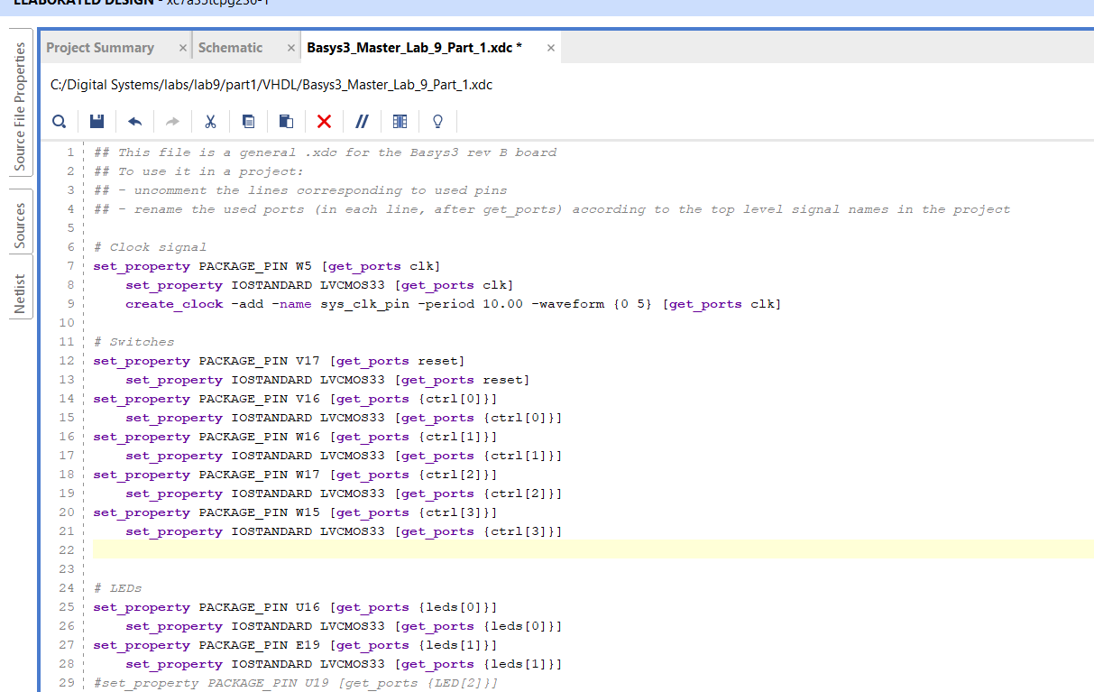

SW4 (ctrl(3)) | SW3 (ctrl(2)) | SW2 (ctrl(1)) | SW1 (ctrl(0)) | Function | LED[1] | LED[0]
0 | 0 | 0 | 0 | Nothing enabled | OFF | OFF
0 | 0 | 1 | 0 | Only LED0 enabled, but no counting | OFF | OFF
0 | 0 | 1 | 1 | LED0 on, Counter 1 counting | OFF | BLINKING
0 | 1 | 0 | 0 | Counter 2 enabled, but LED1 disabled | OFF | OFF
1 | 1 | 0 | 0 | Counter 2 counting, LED1 enabled | BLINKING | OFF
1 | 0 | 1 | 1 | Counter 1 counting, LED0 on, LED1 forced on | LED1=MSB=OLD | BLINKING
1 | 1 | 1 | 1 | Both counters counting, both LEDs enabled | BLINKING | BLINKING

0000 – SW4=0 SW3=0 SW2=0 SW1=0 → leds(0)=OFF, leds(1)=OFF
Description: No counters enabled; both LEDs off.
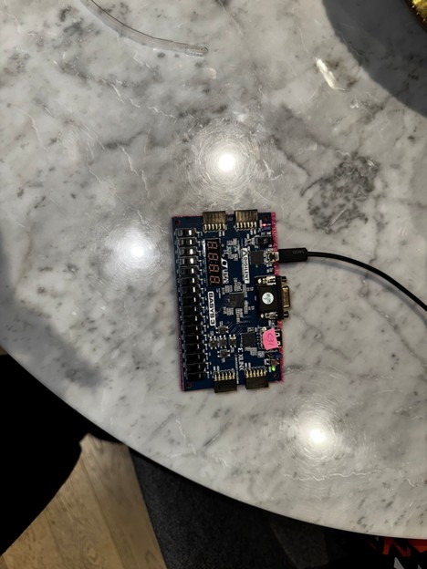
0001 – SW4=0 SW3=0 SW2=0 SW1=1 → leds(0)=OFF, leds(1)=OFF
Description: Counter 1 enabled but not displaying MSB.
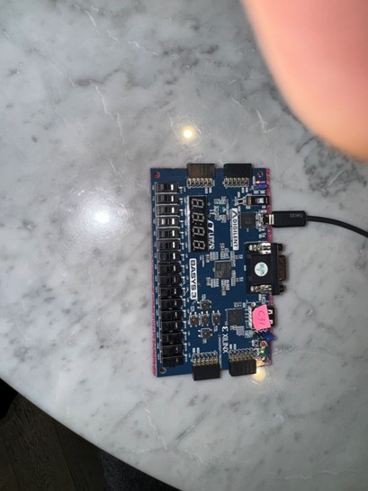
0010 – SW4=0 SW3=0 SW2=1 SW1=0 → leds(0)=BLINKING, leds(1)=OFF
Description: Counter 1 counting and MSB output shown.
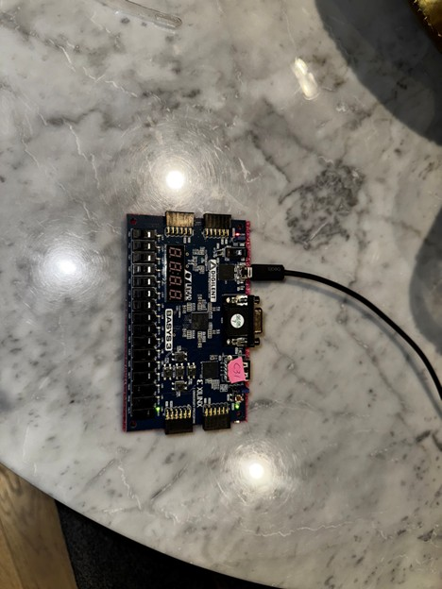
0100 – SW4=0 SW3=1 SW2=0 SW1=0 → leds(0)=OFF, leds(1)=OFF
Description: Counter 2 enabled but LED 1 not enabled.
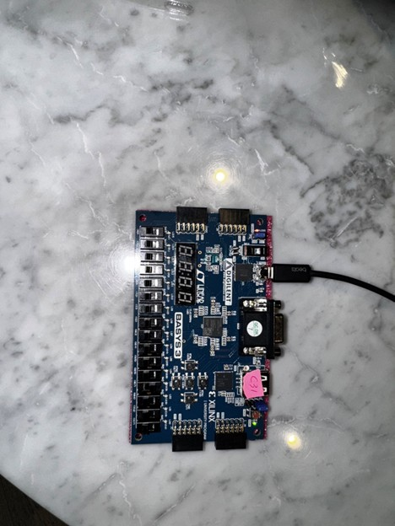
1011 – SW4=1 SW3=0 SW2=1 SW1=1 → leds(0)=BLINKING, leds(1)=ON
Description: Counter 1 counting and MSB shown, LED 1 forced ON.
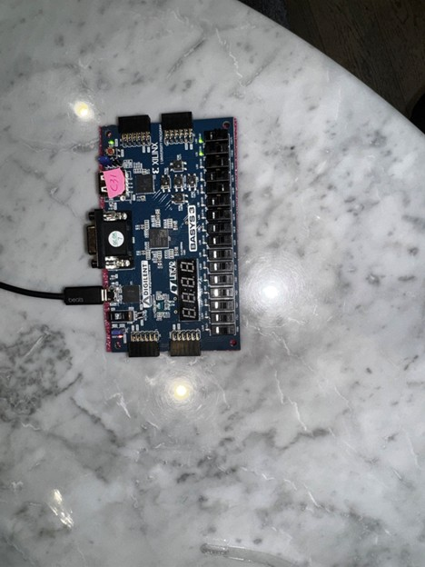
1011 – SW4=1 SW3=0 SW2=1 SW1=1 (again, alternate state) → leds(0)=OFF, leds(1)=ON
Description: Same config, different frame timing (LED 0 low in this snapshot).
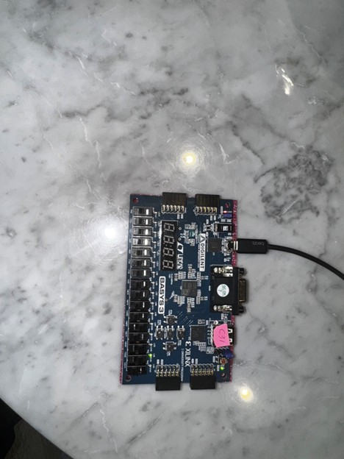
1100 – SW4=1 SW3=1 SW2=0 SW1=0 → leds(0)=OFF, leds(1)=BLINKING
Description: Counter 2 counting, MSB shown on LED 1.
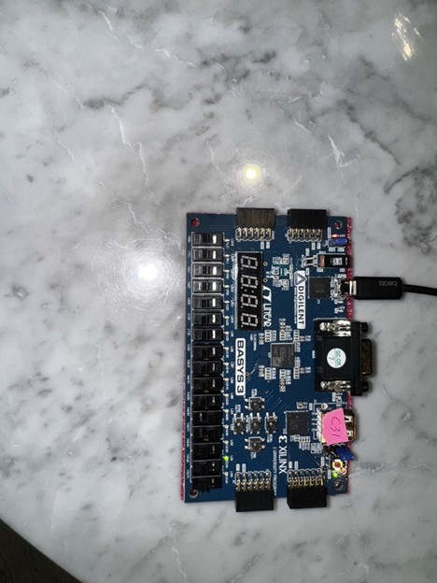
1111 – SW4=1 SW3=1 SW2=1 SW1=1 → leds(0)=ON, leds(1)=BLINKING
Description: Both counters running, LED 0 high (snapshot mid-blink), LED 1 blinking.
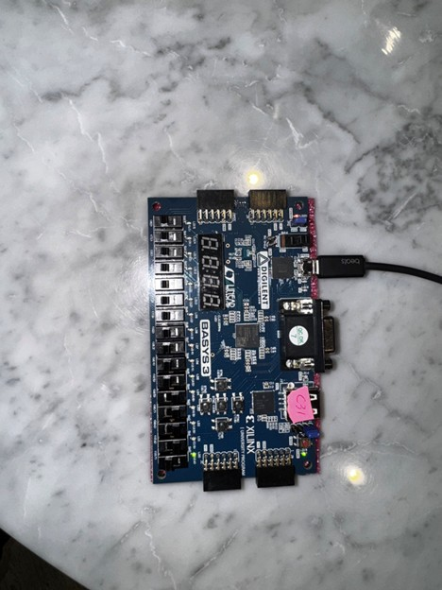
1111 – SW4=1 SW3=1 SW2=1 SW1=1 → leds(0)=BLINKING, leds(1)=ON
Description: Both counters running, alternate state (LED 1 high).
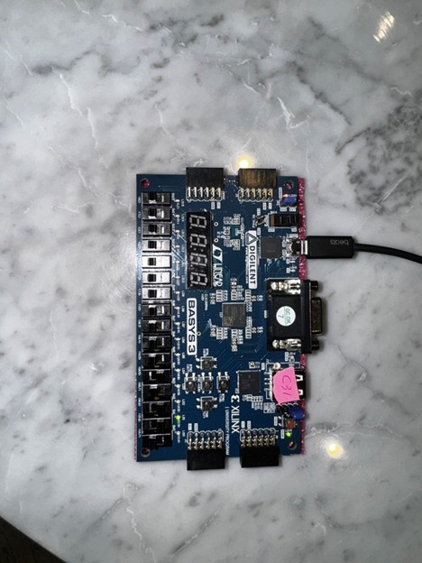
1111 – SW4=1 SW3=1 SW2=1 SW1=1 → leds(0)=OFF, leds(1)=OFF
Description: Snapshot during OFF part of blink cycle (both low).
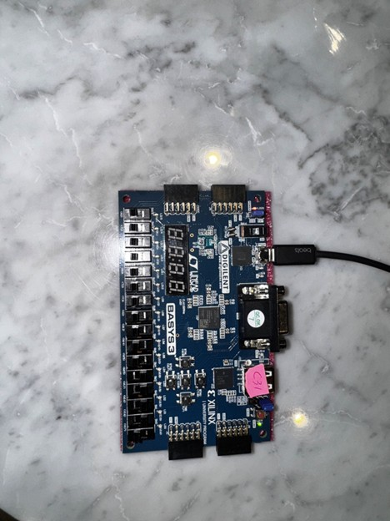

Conclusion of Part 1
This lab successfully demonstrated the implementation and comparison of two counters designed using distinct VHDL methodologies: a non-process-based (combinational) approach for cnter1 and a process-based (sequential) approach for cnter2. By observing the synthesized schematic and testing on the Basys 3 board, it became evident that although both counters perform similar functions, their descriptions affect how the synthesis tool interprets and maps them to hardware.
The Vivado schematic confirmed that both counters were constructed using 30-bit adders, registers, and multiplexers, but the non-process logic resulted in more visibly distributed logic, while the process block grouped control behavior in a more centralized form. Practical testing with control switches further validated the design, as LED[0] and LED[1] correctly responded to MSBs of the respective counters. This exercise deepened our understanding of how VHDL abstraction styles affect not only behavior but also hardware structure and timing.

Part 2
Introduction
In digital systems, it is often necessary to vary the step size of a counter depending on system state, timing needs, or input selection. This part of the lab focuses on implementing two functionally equivalent counters with variable increment values, introducing control logic that modifies how quickly a counter advances based on user input. This reinforces the importance of modular, scalable design in VHDL while building on the foundational concepts of combinational and sequential logic.
The lab extends the previous comparison by introducing two counters—one constructed with selected signal assignment statements and the other using case statements within a process block. Both use a 2-bit control signal to select among four possible increment values: +1, +2, +4, or +8. This setup allows for an in-depth analysis of how different VHDL styles handle multi-path decision-making logic while achieving identical functionality.
Concept
This section introduces control-driven counter behavior using VHDL constructs suited for conditional branching. Counter 1 leverages the with-select signal assignment, offering a compact and readable method for mapping specific control values to defined increment values. Counter 2 is constructed using a case statement within a process block, which is ideal for sequential designs that may be expanded to support more complex state transitions in future designs.
Both counters share the same architecture: a 30-bit unsigned register and a 2-bit control input. The user selects an increment value based on the switch position, and the LED connected to the most significant bit (MSB) of the counter visually indicates how quickly the count progresses. This exercise not only reinforces the importance of correct signal handling and state transitions but also provides insight into hardware design practices such as decode logic, multipath control, and sequential data flow management.
Procedure
- A new Vivado project was created with VHDL selected as the design language and the Basys 3 FPGA board chosen as the target hardware platform.
- The VHDL design was written according to the lab requirements:
- Counter1 was implemented using selected signal assignment (with-select) to vary the increment by control input ctrl1.
- Counter2 was implemented using a case statement inside a process block, with the same functionality, but driven by control input ctrl2.
- The design source file containing both counters and LED output logic was saved and added to the project.
- The Basys 3 constraint file (.xdc) was edited:
- The reset, clk, ctrl1(1 downto 0), ctrl2(1 downto 0), and leds(1 downto 0) ports were mapped to physical switches and LEDs on the FPGA.
- Care was taken to match the signal names exactly with those in the VHDL entity declaration.
- The Linter tool was run to check for syntax issues, and the “Open Elaborated Design” tool was used to view the synthesized RTL schematic.
- A snapshot of the schematic was taken and used to analyze and compare the structure of Counter1 and Counter2.
- The project was synthesized, implemented, and a bitstream was generated and programmed to the Basys 3 FPGA.
- The design was tested by toggling the four switches connected to ctrl1 and ctrl2:
- The blinking speed of LED[0] (Counter1 MSB) was tested for each ctrl1 value.
- The blinking speed of LED[1] (Counter2 MSB) was tested for each ctrl2 value.

Code Snapshot
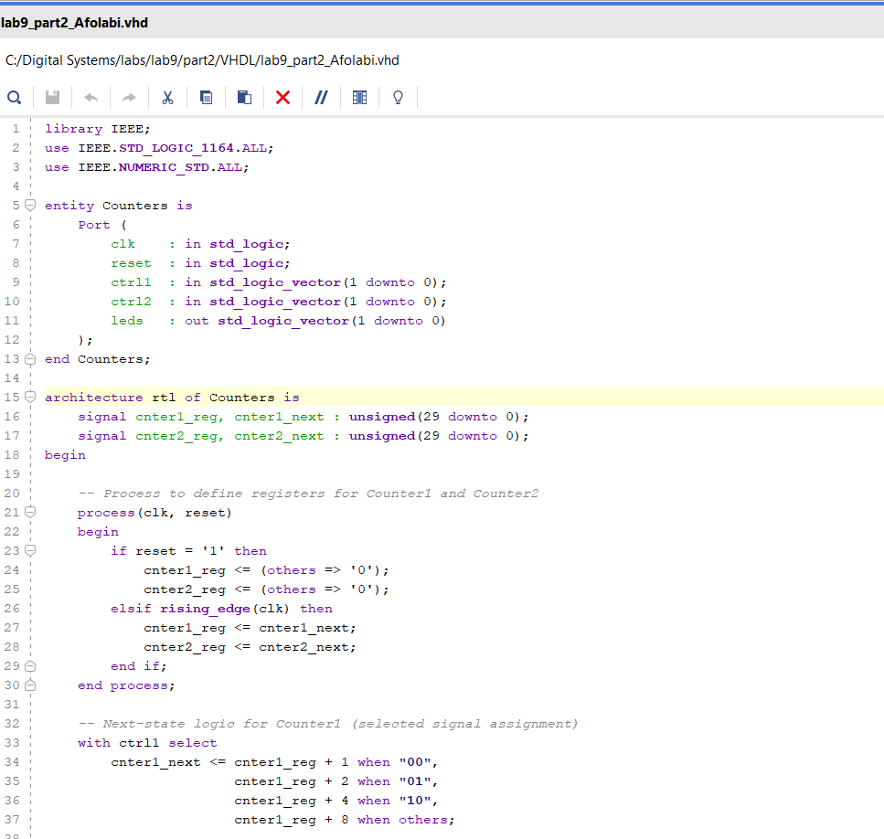
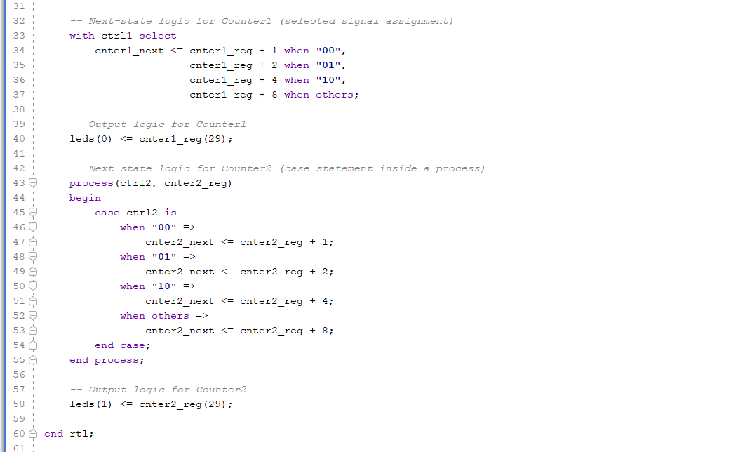
Vivado Schematic
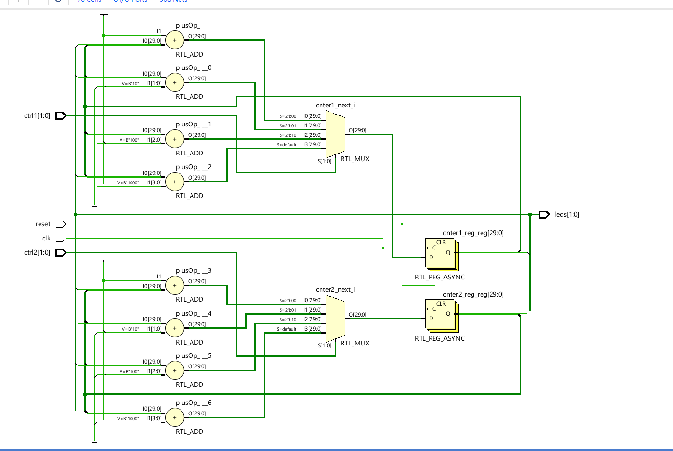
Components of the Schematic and relationship with VHDL Code
VHDL Construct | Schematic Component | Label in Schematic
cnter1_next <= cnter1_reg + X (with-select style) | 4 Adders + 1 4:1 MUX | plusOp_i, plusOp_i_0 to _2, cnter1_next_i
Register for cnter1_reg | 30-bit asynchronous register | cnter1_reg_reg[29:0]
Output to LED: leds(0) <= cnter1_reg(29) | Bit slice to LED port | leds[0]
case block computing cnter2_next | 4 Adders + 1 4:1 MUX | plusOp_i_3 to plusOp_i_6, cnter2_next_i
Register for cnter2_reg | 30-bit asynchronous register | cnter2_reg_reg[29:0]
Output to LED: leds(1) <= cnter2_reg(29) | Bit slice to LED port | leds[1]
Control input ctrl1, ctrl2 (select input to MUXs) | Multiplexer selector logic | S=2'b00 … on both MUXes
Clock and Reset handling | Connected to both register blocks | clk, reset

Comparison of Part 2 counters
(1) Are there any differences?
No significant functional differences are observed. Both cnter1 and cnter2 are implemented with:
- A 30-bit adder
- A 4:1 MUX selecting between +1, +2, +4, +8
- A 30-bit register
- LED output from MSB (bit 29)
Even though different VHDL styles were used:
- with-select (declarative style for cnter1)
- case inside process (sequential control logic for cnter2)
Vivado synthesized functionally equivalent hardware for both.

(2) What did you learn from the comparison?
- VHDL abstraction style doesn’t limit functionality: The same hardware can be described in multiple ways using different VHDL styles.
- Vivado optimization is powerful: It can interpret different styles (e.g., with-select and case) into identical logic structures, especially when the logic is deterministic.
- Readable code vs. scalable design:
  - with-select is clean and short for small MUX-based logic.
  - case inside a process gives more flexibility, especially useful in FSMs or complex conditional branching.
- This reinforces the principle that RTL design style can influence synthesis structure, but tools like Vivado aim to generate optimal hardware regardless of coding method.

Constraint File Snapshot
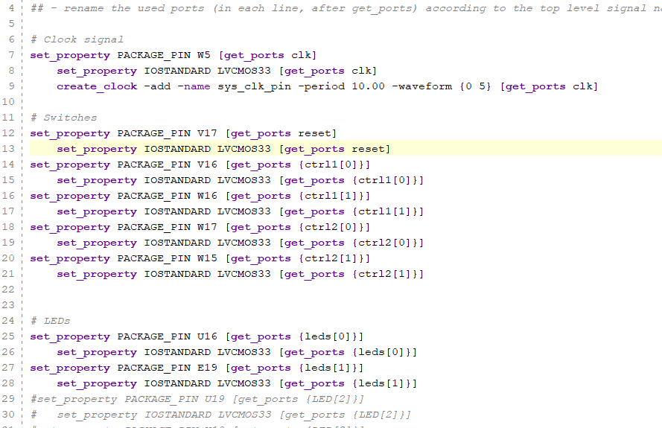
Results:
Counter 1
ctrl1(1 downto 0) | Switch Setting | LED[0] Behavior
"00" | SW2=0, SW1=0 | Slow blink (increment +1)
"01" | SW2=0, SW1=1 | Faster blink (+2)
"10" | SW2=1, SW1=0 | Faster blink (+4)
"11" | SW2=1, SW1=1 | Fastest blink (+8)

Counter 2
ctrl2(1 downto 0) | Switch Setting | LED[1] Behavior
"00" | SW4=0, SW3=0 | Slow blink (increment +1)
"01" | SW4=0, SW3=1 | Faster blink (+2)
"10" | SW4=1, SW3=0 | Faster blink (+4)
"11" | SW4=1, SW3=1 | Fastest blink (+8)

Conclusion of Part 2
This lab successfully demonstrated the implementation of two functionally equivalent counters using different VHDL design techniques—selected signal assignment (with-select) and case statements within a process block. Both counters were designed to increment by variable step sizes of +1, +2, +4, or +8, based on a 2-bit control input. The output of each counter’s most significant bit was observed through on-board LEDs on the BASYS 3 FPGA.
Through synthesis and schematic analysis in Vivado, it was confirmed that despite stylistic differences in VHDL, both counters synthesized into equivalent hardware structures. Each counter used a 4-to-1 multiplexer, a 30-bit adder, and a 30-bit register. This reinforces a key RTL design principle: multiple VHDL coding styles can yield identical functional and structural results if written carefully.
Testing with switch configurations validated the expected functionality. The LEDs blinked faster with higher control input values, verifying correct increment behavior. This part of the lab emphasized the flexibility of behavioral VHDL and the value of style-conscious design. It also showed how Vivado abstracts control logic through synthesis, confirming that both with-select and case approaches are viable in real-world digital system design.

